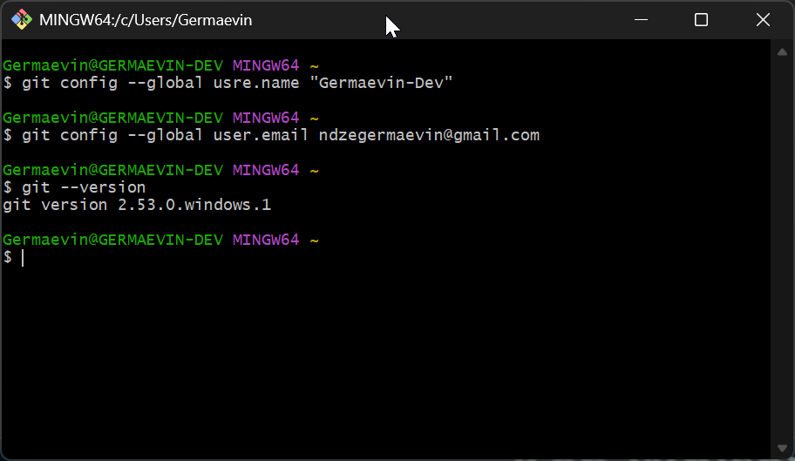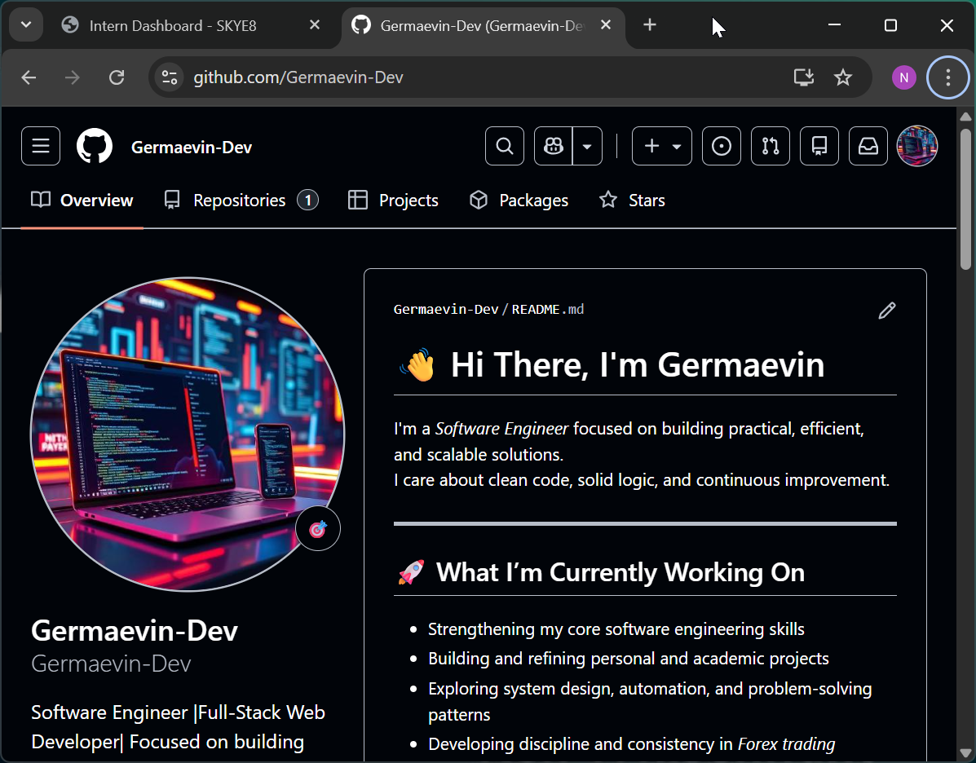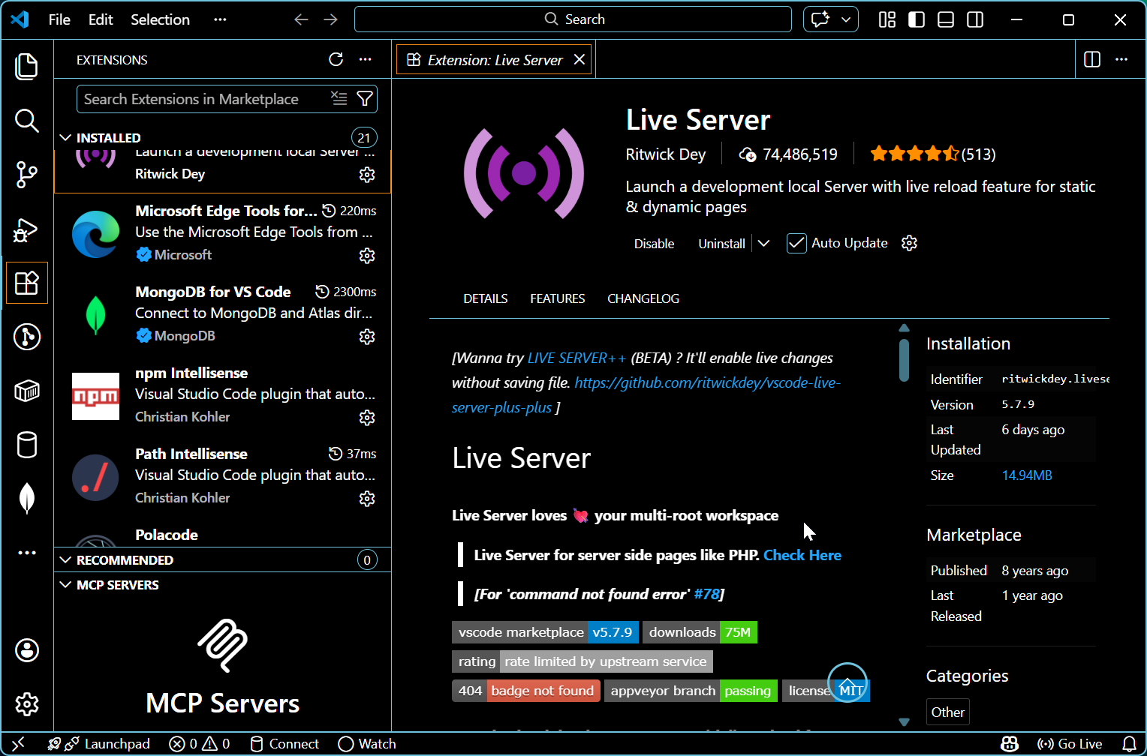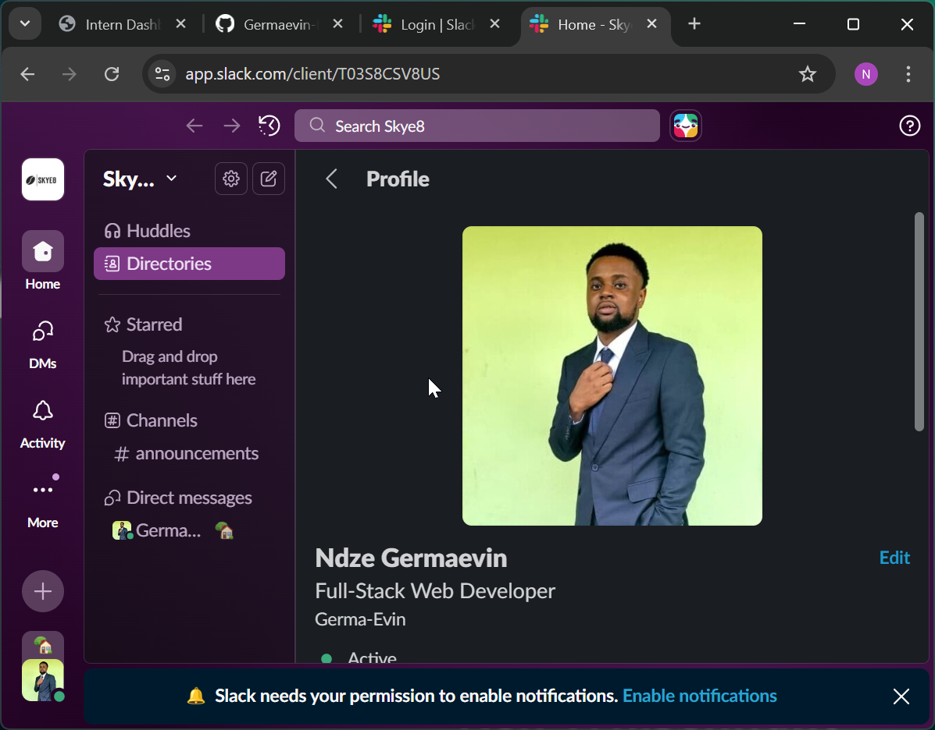GITHUB:https://github.com/Germaevin-Dev
SLACK USERNAME:Ndze Germaevin(Germaevin-Dev)

SYSTEM SPECIFICATIONS
- GIT: Used for writing command prompts
- GITHUB: Used for pushing repositories online
- VSCODE: Used for coding programs(HTML,CSS,JAVASCRIPT,REACT)etc
- SLACK: Used for communication with colleagues at SKY8
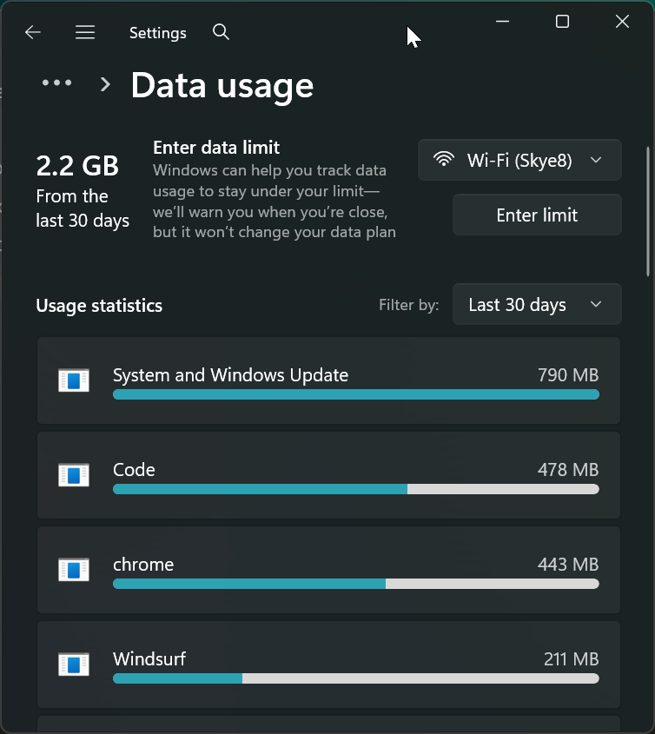
SK8 Internet speed.

INTRODUCTION:
My Name is NDZE GERMAEVIN NJINI, i am a Software Engineering Student at the NPUI of bamenda, currently in my 3rd year of studies in the faculty of Computer Science And Technology, and i am aspiring to gain my certificate in a the degree program i am currently working on. I hope to learn as much as I can at my internship program here at SKY8.

https://github.com/Germaevin-Dev/Internship-Onboarding-Ndze-Germaevin-.git

